Market Rabbits
Supplies:
2- 32oz Water bottle - Roller ball nipple
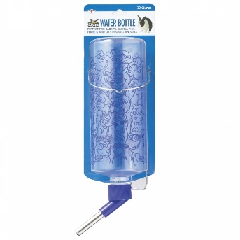

2- Medium to large metal feeders
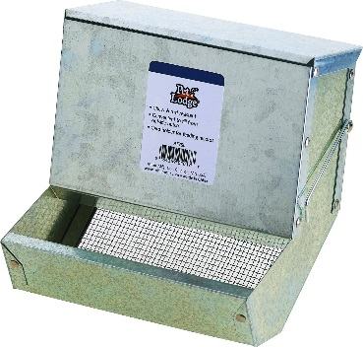

1-Wire floor transport cage / multiple compartments
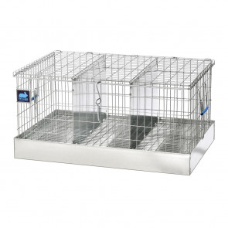
Coastal Hay - will need only for the first 10 days (or if the rabbit becomes stressed)
Cleaning Supplies – Stiff-Bristled Brush, Scraper, Kitty Litter Scooper, Mild Disinfectant, Bottle Brush
Recommended Feed: (best to good); you want a feed that is 16-17% Protein- nothing higher/lower
- Petrus Elite
- Bluebonnet
- Purina
- Show Rite
** ALWAYS MAKE SURE THE FEED IS FRESH - DO NOT FILL THE FEEDER**

Some Do’s and Don’ts on Rabbits:
- The first 10 days you have your rabbits are critical – make sure to provide the hay (handful only) and probiotics; DO NOT HANDLE your rabbits during this time.
- Rabbits should be housed and transported in a wire floored cage to prevent injury; Always transport inside the vehicle
- Make sure the pen is away from pets (barking dogs, cats, outdoor rodents/pest), severe climate (cold or heat), and heavy winds.
- No weights will be taken on the rabbits for the first 2 weeks; we will start weighing the last 10-15 days before the show- daily!
- Begin working fur and practice posing your rabbits the last 10-15 days before show - you want them to be somewhat tense when the judge handles them - if they are handled too much they will not pose properly.

